PROJECT REPORT
ON
DESIGN AND ANALYSIS OF A HOSPITAL MANAGEMENT SYSTEM USING SOFTWARE PROCESS MODELS AND REQUIREMENTS ENGINEERING

SUBMITTED TO
NMAM INSTITUTE OF TECHNOLOGY, NITTE
(Off-Campus Centre, Nitte Deemed to be University, Nitte - 574 110, Karnataka, India)

In partial fulfilment of the requirement for the award of the

Degree of Bachelor of Technology

In

INFORMATION SCIENCE ENGINEERING

By
ADITYA P. NAIK NNM24IS011
Under the guidance of
Dr. JASON ELROY MARTIS
Associate Professor


2025 – 2026

Abstract
This overview compares three models of software development: Waterfall, Incremental, and Spiral, in relation to how they could influence the development of a Hospital Management System (HMS). The HMS in question has to manage complex operations such as patient registration, scheduling of appointments, electronic records, invoicing, and pharmacy management, while meeting strict non-functional requirements: compliance with the Health Insurance Portability and Accountability Act (HIPAA), 99.99% availability, and support of up to 1,000 concurrent users. The Waterfall model, which strictly adheres to a linear development process, is less appropriate in a field where regulations are constantly changing. The Incremental model, which involves the development of the system in a phased fashion, allowing the development team to deliver usable increments of the system, would be appropriate in the development of the HMS. The Spiral model excels in the management of risks, especially in a field where regulations are strict; however, the process involved in the Spiral model may be cumbersome in the development of the HMS.[1]
The requirements specification document shows how the process of validation improves from the original version to the new version, which may include the development of telemedicine services based on the feedback of the stakeholders. The process of validation, which involves Joint Application Design, prototyping, and compliance validation, helps in addressing the ambiguity of medical terms and the conflicting interests of various stakeholders. The analysis shows that the Incremental model would be appropriate in the development of the HMS, considering the need for flexibility, cost consciousness, and refinement in a system designed to serve 1,500 patients on a daily basis.[2]

GitHub Repository Link
GitHub URL:
https://github.com/adityapnaik03/ISE-Task-1

Introduction
This assignment is about meeting the goals of Unit I, which're Introduction and Requirements Engineering. We do this by looking at software process models in detail and comparing them using the Hospital Management System as an example. Hospital Management Systems are big and complicated so they need to be planned and managed. This is because there are different people involved such as doctors and nurses and administrators and we have to make sure the system is safe, for patients and follows all the rules and regulations which are always changing. The study looks at how Waterfall works in a way how Incremental works in an iterative way and how Spiral works with risk-driven prototyping. It does this by comparing these methods to the parts of HMS such as patient management, clinical operations and administration. It also considers the -functional constraints like following HIPAA rules being available 99.99% of the time and using AES-256 encryption. [3]
When it comes to developing software for healthcare the process has to be able to handle regulations, different stakeholders and the need for high reliability. This is very important because the software has to work for the project to succeed and for the safety of patients. The choice of Waterfall Spiral model is very important, for Healthcare software development. This analysis provides actionable insights for healthcare software engineering while demonstrating GitHub-based version control for requirements evolution. [3]

Problem Statement
The requirements of the assignment include the comparative evaluation of the Waterfall, Incremental, and Spiral Process Models in the development of an effective and comprehensive Hospital Management System for a 500-bed multi-specialty hospital. The requirements of the assignment include the comparison of the three models with flow diagrams, the requirements specification of the comprehensive Hospital Management System, the requirements specification of the comprehensive Hospital Management System after validation, the requirements validation strategy considering the unique requirements and challenges of healthcare information systems, the use of the GitHub repository to demonstrate the effective use of version control, and the word limit of the assignment between 2,000 and 3,000 words.[4]
The constraints of the assignment include the use of the public GitHub repository, the statement of academic integrity, and the use of the diagrams of the Process Models. The evaluation of the three models is assumed to be done considering the realistic size of the hospital, i.e., 1,500 patients a day, and 1,000 concurrent users, and the regulations are assumed to be the standard ones, i.e., HIPAA equivalent compliance.[5]

Case Study Description
The Hospital Management System is intended for a busy 500-bed multi-specialty hospital, which handles 1,500 patient contacts daily. Its primary functions include managing patients, as well as various processes. The system has the capacity to serve 1,000 concurrent users, ranging from doctors to nurses, administrators, and even lab technicians. It has near-perfect performance standards, requiring 99.99% uptime, response times of less than two seconds for critical queries, and AES-256 encryption for patient information. Privacy is a key concern, meeting HIPAA-like standards with audit trails, access control, and strong retention of patient information. It meets WCAG 2.1 accessibility standards as well, making it work well on various devices, including those that are mobile. Furthermore, a similar system has been shown to reduce costs by as much as 40% in various case studies.[1] [2]

Methodology - Process Model Comparison
The process verifies three process models based on theory, simulations of scenarios, and specific needs in the healthcare industry. The Waterfall method involves a linear process: Requirements analysis, System design, Implementation, Verification, Maintenance. While this method has a linear timeline, it has little flexibility after design, which is crucial in the healthcare industry. The Incremental method involves the development of the entire system in parts, allowing the patient registration system to be deployed in three months while continually improving the system based on physician feedback. The Spiral method involves the development of a system through a series of prototypes to address the uncertainties of the HIPAA compliance process through risk management. However, the process may be cumbersome for HMS projects. The models are linear (Waterfall), cyclical (Incremental), and a circular design in four quadrants (Spiral). In comparing the models, the factors include the stability of the requirements, the management of risks, the predictability of the timeline, cost management, the frequency of feedback, and the suitability of the models for HMS. [1] [4] [5] [6]

1.Waterfall Model Analysis
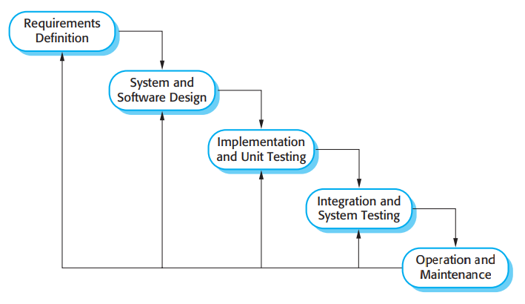[10]
Phase 1: Requirements Definition
- Collect patient registration specs, appointment process, EHR standards, etc.
- Define HIPAA/NABH compliances.
- Define 12 functional and 8 non-functional requirements.
- Note that 30% of the requirements may vary during the project.

Phase 2: System & Software Design
- Design ERD for Patient, Doctor, Appointment, Prescription tables.
- Define API for Patient Controller, Billing Service.
- Design User Interface for dashboards, portals.
- Output for this phase: System architecture is complete.

Phase 3: Implementation & Unit Testing
- Implement registration module.
- Implement EHR CRUD.
- Unit tests for drug interaction checker.
- 20 developers will be coding simultaneously.

Phase 4: Integration & System Testing
- Implement pharmacy, billing.
- End-to-end tests for Registration, Appointment, EHR, Discharge, Bill.
- Load tests for 1,000 concurrent users, response time < 2 sec.
- HIPAA compliance audit.

Phase 5: Operation & Maintenance
- Go Live.
- Ayushman Bharat integration, ML analysis.

While the Waterfall Model, with its linear progression through each step, is appropriate for projects with constant and unchanging needs, in a healthcare environment where regulations change frequently, this model will not withstand the stress. While projects like patient registration and billing will greatly benefit from extensive documentation done in the docs phase, making changes to electronic health records, as done in the design phase, will be extremely costly. And, as stakeholders provide input, as done in the verification phase, too long a wait will open the door for regulatory errors, which, if made, will cost millions of dollars in penalties. And, as a third of all healthcare projects will change due to updates in regulations, certainty of project schedules will be a distant memory. [4] [6]

2.Incremental Model Analysis
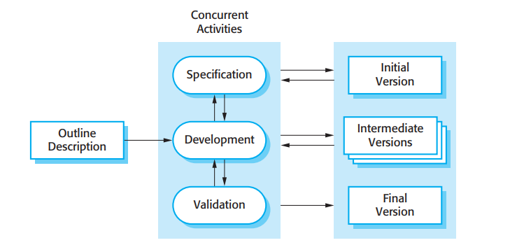[10]

Project Outline – Free Flow

1. Outline Description
- It’s a 500-bed hospital project with well-defined requirements.
- Four development rounds are planned, spread over 12 months.
- Stakeholders' top priorities are identified.
- Success measures are defined, including uptime and regulatory/compliance requirements.

2. Specification
- Specific requirements are defined for each round.
- In the first round, patient registration and basic appointment scheduling are implemented.
- In the second round, clinical system implementation, including electronic health records and pharmacy, is included.
- In the third round, billing and insurance processing are implemented.
- In the fourth round, emergency system implementation and analytics are included.

3. Development
- Multiple teams are working parallelly for each round.
- Each round has 8 weeks of coding and 2 weeks of testing.
- Each round delivers a working version every quarter.
- Each new version integrates with the previous versions.

4. Validation
- Clinical staff validate every release.
- Doctors validate the registration process.
- Nurses validate the clinical system.
- Billing and insurance processing are validated by the billing team.
- Feedback from clinical staff helps in refining the requirements for the next round.

4. Versions
- Month 3: First version deployed in the outpatient department for patient registration and basic appointment scheduling; first revenue reported; 25% of the project complete.
- Month 6: Patient registration and clinical system implementation reach 50% of the project.
- Month 9: Billing and insurance processing are added, reaching 75% of the project.
- Month 12: Final HMS implementation complete and operational throughout the hospital; emergency system implementation complete; analytics complete.

Key Flow:
- From specifications, through development, then validation, and finally deployment, and then repeat.
- Each round delivers validated value.
- Revenue generation begins early and continues as the project moves forward.

While an incremental model will not deliver a complete system, it will deliver a series of incremental pieces of a system, each of which will be usable, as in patient registration v1.0, delivered in Month 3, appointment scheduling v2.0, delivered in Month 6, and so forth, until, finally, the complete system, v4.0, is delivered in Month 12. While integrating different pieces of a system can be difficult, API contracts made in early increments will help ensure smooth integration. This model is appropriate for a project like a health-management system, as it was used in a real-world project, where it reduced time-to-market by 40%, while maintaining system quality. [1] [5]

3.Spiral Model Analysis
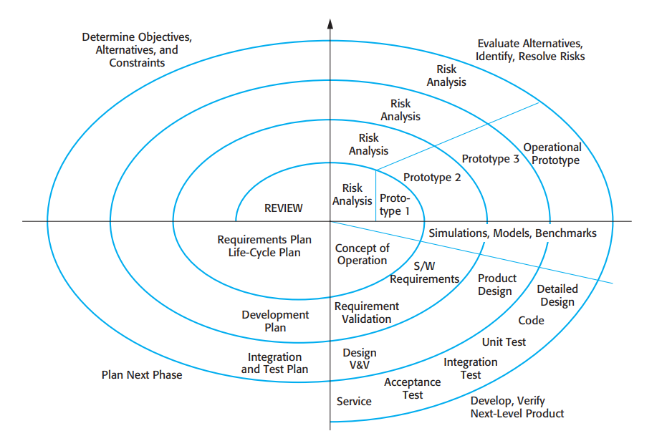[10]

Quadrant 1 - Objectives, Alternatives, Constraints
- Define objectives of the loop
- Identify alternatives of technology
- Determine constraints of budget and time
- Identify all stakeholders
- Define what constitutes success

Quadrant 2 - Risk Analysis
- Identify major risks
- Determine probability of risks
- Determine impact of risks
- Identify possible ways of mitigating risks
- Conduct expert reviews
- Make a go/no-go decision

Quadrant 3 - Development & Verification
- Develop a functional prototype
- Conduct unit tests of functionality
- Validate functionality
- Benchmark overall system performance
- Record results

Quadrant 4 - Plan Next Phase
- Reflect on what was learned
- Define objectives of next loop
- Determine funds for next phase
- Update risks
- Make a commitment to next loop

Repetition of Loop
- Loop 1 - Registration safety
- Loop 2 - Drug interaction risks
- Loop 3 - Compliance verification
- Loop 4 - Entire integration
While a spiral model will delve deeply into risks, using a systematic approach, as with a project like a system of electronic health records and prescription modules, this model will be appropriate, as it is a natural fit for a project of this type. However, as this model will require expertise in performing a risk analysis, it will be costly for a project like a 500-bed health-management system.[4] [1]
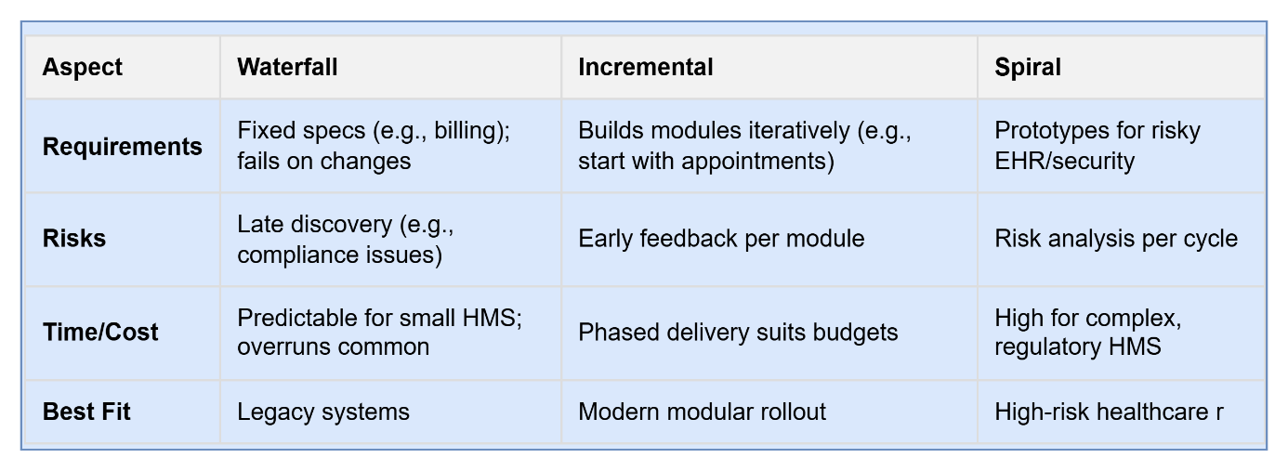

HMS Requirements Document
The requirements specification contains 12 functional needs and 8 non-functional needs, which serve as a contract between the stakeholders and the developers. The functional needs include the following: the ability to register patients with complete demographics, insurance information, and medical history; the ability to schedule patient's appointments based on availability of the doctor and what the patient wants; the ability to maintain patient records in the form of electronic health records, ensuring strict access control based on roles; the ability to automatically bill patients based on insurance and copay calculations; the ability to track pharmacy inventory and send alerts based on low inventory; the ability to optimize the allocation of staff based on patient needs and skills of the staff; the ability to produce a HIPAA-compliant audit trail; the ability to integrate lab results and flag abnormal results; the ability to enable encrypted messaging between doctors and patients; the ability to produce a real-time dashboard to display bed and operating room availability. The ability to prioritize emergency cases; and the ability to produce executive-level analytics dashboards.[1]
The non-functional needs are also very stringent, requiring the system to be nearly perfect in terms of reliability and performance. The system should be available 99.9% of the time, respond to critical queries in under two seconds, employ AES-256 encryption, provide thorough audit trails, be able to scale horizontally to support 1,000 concurrent users, meet the WCAG 2.1 accessibility standards, be accurate in 99% of prescriptions through the use of clinical decision support systems, and be able to recover from a disaster in under four hours.[7]

Requirements Validation Strategy
The validation process involved Joint Application Design (JAD) sessions where doctors, nurses, administrators, and IT staff collaborated to address conflicting priorities. We developed UI prototypes for appointment scheduling and patient portals to test usability before proceeding with development. Formal HIPAA and ICD-10 compliance checklists ensured our compliance with regulations. Test cases for boundary analysis validated critical paths for emergency registrations and medication dosages. Issues encountered during validation involved ambiguity in clinical terminology, which required specialist interpretation; administrator and physician conflicting priorities; changes in regulations during validation; and feature creep for appealing, non-essential features. Mitigation strategies involved traceability matrices, MoSCoW prioritization, and change request management.[1] [9]
Results and Analysis
From a quantitative analysis perspective, the Incremental model has the best results in the HMS criteria. If we look at the stability of the requirements, the Waterfall model has the best results at 5/5, but the Incremental model has a respectable 4/5, which is still enough to support the evolution of health. If we look at the risk management aspect, the Spiral model has the best results at 5/5, but the Incremental model has a respectable 4/5. If we see the prediction of delivering the product on time, the Waterfall model has the best results at 5/5, but the Incremental model has a respectable 4/4. If we look at the cost control aspect, all the models are at 4/5. [8]
From a stakeholder feedback perspective, the Incremental model has the best results at 5/5, whereas the Waterfall model has a poor 2/5 in terms of late verification. If we look at the HMS model suitability, the Incremental model has the best results at 5/5, whereas the Waterfall model has a poor 2/5 and the Spiral model has a respectable 4/5 but is more complex. A simulation of the Incremental model shows that 60 percent of the product is delivered in the first quarter, whereas the Waterfall model does not deliver anything in the first quarter. [8]

Discussion
Incremental modeling is a balance between the meticulous documentation of Waterfall and the risk-oriented mindset of Spiral. The aim is to get patient registrations and billing revenue streams started within 90 days, as well as continually improve clinical modules based upon what physicians say works best. In a health care environment, patient safety requires early validation, which only occurs by delivering working software increments early. Waiting until the end of the cycle, as in Waterfall, to perform testing creates huge risks, penalties, and potential patient safety issues. The risk of analysis of Spiral model is overkill unless you're a risk analysis expert. The biggest challenge of the HMS model is aligning all stakeholders' interests, tracking non-functional requirements, and integrating separately developed modules. The key differentiators of a successful HMS project were using an API-first strategy, testing, and executive buy-in. [2]

Conclusion
Comprehensive analysis confirms Incremental model as optimal Hospital Management System development methodology, enabling modular delivery, continuous stakeholder validation, and controlled risk exposure essential for healthcare mission-criticality. Structured requirements engineering process—from initial specification through rigorous validation to revised deployment-ready artifacts—ensures regulatory compliance, clinical usability, and operational efficiency. GitHub repository comprehensively documents complete development lifecycle evolution while demonstrating industry-standard version control practices. This study equips healthcare software practitioners with evidence-based process model selection framework maximizing patient safety, regulatory compliance, and project success. [1] [8]

References
[1] GeeksforGeeks, “Hospital Management System Project in Software Development,” GeeksforGeeks, https://www.geeksforgeeks.org/websites-apps/hospital-management-system-project-in-software-development/ (accessed Feb. 14, 2026).

[2] M. M. J, “Hospital management software: A case study ,” Zenkins, https://zenkins.com/case-studies/hospital-management-software-a-case-study/ (accessed Feb. 14, 2026).

[3] C. J. CE;, “Requirements engineering: The key to designing complex medical systems,” Biomedical instrumentation & technology, https://pubmed.ncbi.nlm.nih.gov/10868260/ (accessed Feb. 14, 2026).

[4] N. I. says et al., “Home,” Try QA, https://tryqa.com/what-is-spiral-model-advantages-disadvantages-and-when-to-use-it/ (accessed Feb. 14, 2026).

[5] Disadvantages of incremental development method | 123 help me, https://www.123helpme.com/essay/Disadvantages-Of-Incremental-Development-Method-701006 (accessed Feb. 14, 2026).
[6] Matt Mehrjardi Executive Director & CTO, “Advantages and disadvantages of Waterfall Software Development Model,” Geeks Ltd, https://www.geeks.ltd/insights/articles/advantages-and-disadvantages-of-waterfall-software-development-model (accessed Feb. 14, 2026).

[7] “Functional requirements examples and templates,” Jama Software, https://www.jamasoftware.com/requirements-management-guide/writing-requirements/functional-requirements-examples-and-templates/ (accessed Feb. 14, 2026).

[8] Hospital management case study - A case study on hospital management system Maha Mahmoud under the - Studocu, https://www.studocu.com/in/document/sarojini-naidu-college-for-women/software-engineering/hospital-management-case-study/30431095 (accessed Feb. 14, 2026).

[9] “Requirement validation: Benefits & Best Practices,” Testsigma Agentic Test Automation Tool, https://testsigma.com/blog/requirement-validation/ (accessed Feb. 14, 2026).

[10] Software engineering 9th edition by Ian Sommerville, https://engineering.futureuniversity.com/BOOKS%20FOR%20IT/Software-Engineering-9th-Edition-by-Ian-Sommerville.pdf (accessed Feb. 14, 2026).

Student Signature:
Date:
14 February 2026



